DEEP LEARNING-BASED BREAST CANCER DETECTION USING CONVOLUTIONAL NEURAL NETWORKS

Abstract
One of the prevalent causes of mortality globally is breast cancer. Hence, an accurate computer-assisted diagnostic system for diagnosing the condition is required. In this project, an image classification model to distinguish between benign and malignant images of breast cancer was designed based on ResNet50-based transfer learning. Images of the BreakHis dataset were preprocessed, scaled, normalised, and partitioned into training, validation and testing datasets. A pre-trained ResNet50 network architecture was adopted for feature extraction. While Global Average Pooling were implemented, a sigmoid activation function was used for binary classification. Implementation of the model was done using Google Colab with Python, TensorFlow and Keras. During the compilation and training process, the binary cross-entropy loss function and Adam optimiser were employed. Evaluation metrics included accuracy, precision, recall, F1 score, balanced accuracy and confusion matrix. The model achieved approximately 70.16% accuracy based on the confusion-matrix evaluation and showed substantially higher recall for malignant images than benign images. However, benign recall was only 5.44%, indicating substantial prediction bias towards the malignant class. This research has shown that transfer learning is a viable technique for automated classification of breast cancer images; nevertheless, overall accuracy cannot fully describe the reliability of the model.
Keywords: ResNet50, BreakHis, Histopathological, and Transfer learning.

Table of Contents
1. Introduction 4
1.1 Background of the Study 4
1.2 Problem Statement 4
1.3 Aim and Objectives 5
1.4 Project Motivation and Significance 5
1.5 Project Scope 6
1.6 Project Template and Methodology 6
1.7 Chapter Summary 6
2. Literature Review 7
2.1. Introduction 7
2.2. Traditional Breast Cancer Detection Methods 7
2.3. Deep Learning in Medical Image Analysis 8
2.4. Review of Previous Studies on Breast Cancer Detection 8
2.4.1 CNN-Based Detection Models 8
2.4.2 Transfer Learning Approaches 9
2.4.3 Comparative Analysis 10
2.4.4 Existing Breast Cancer Detection Systems 12
2.5. Research Gaps in Existing Literature 13
2.6 Chapter Summary 13
3. Project Design 14
3.1 Introduction 14
3.2 Project Design 14
3.3 Domain and Target Users 15
3.4 Dataset Selection and Management 15
3.5 Technologies and Methods 17
3.6 Project Plan 17
3.8 Evaluation Strategy 18
3.9 Chapter Summary 19
4. Implementation 19
4.1 Introduction 19
4.2 Model Architecture 19
4.3 Development Environment 22
4.4 Transfer-Learning Implementation 22
4.5 Feature Aggregation and Classification 23
4.6 Model Compilation 23
4.7 Chapter Summary 24
5. Evaluation 24
5.1 Introduction 24
5.2 Class Distribution 24
5.3 Training and Validation Performance 26
5.4 Overall Test Performance 26
5.5 Confusion-Matrix Analysis 27
5.6 Class-Level Performance 28
5.7 Effect of Class Imbalance 29
5.8 Comparison With the Baseline 30
5.9 Limitations of the Evaluation 31
5.10 Chapter Summary 31
6. Conclusion 31
6.1 Conclusion 31
6.1 Recommendations 32

1. Introduction

1.1 Background of the Study
Breast cancer is one of the most common cancers impacting women in the world and also remains a significant public health concern. As per the global cancer statistics, breast cancer accounts for a massive proportion of cancer-related morbidity and mortality among women that makes early detection and reliable treatment important for enhancing the outcomes of the patients (WHO, 2025). Early breast cancer detection can improve treatment opportunities and reduce disease progression (Khan et al., 2025). On the other hand, healthcare systems place considerable emphasis on screening and diagnostic programmes. Various conventional diagnostic techniques are presently used for breast cancer identification such as mammography, ultrasound imaging, magnetic resonance imaging (MRI), and biopsy procedures. Mammography is the most widely integrated screening method because of its capability to detect abnormalities in breast tissue before symptoms. However, interpretation can vary with clinical expertise and experience, potentially contributing to diagnostic inconsistency (Karera et al., 2024). Along with that, false positive and false negative results may occur resulting in unwanted processes, late treatment and higher patient anxiety. Current advancements in Artificial Intelligence (AI) and Deep Learning have created new opportunities to improve medical image analysis. Therefore, Convolutional Neural Networks (CNNs) have been described as having strong abilities in automatically determining complicated patterns within medical images.

1.2 Problem Statement
Breast cancer diagnosis initially relies on the application of medical images by radiologists and healthcare specialists. However, mammography, ultrasound, and biopsy procedures are widely used for screening and diagnosis, and the accuracy of these methods is influenced by human expertise and experience. Medical images may contain subtle morphological abnormalities that are difficult to interpret consistently, potentially contributing to variation between clinicians (Hussain et al. 2022). As a result, false positive and false negative outcomes might occur that causes unnecessary medical procedures, delayed treatment, and increased patient anxiety. The increasing number of breast cancer screening programmes has similarly resulted in a significant rise in the number of mammographic images that need to be analysed. This increases the workload on caregivers and can also cause diagnostic fatigue and decreased productivity. In addition, manual interpretation may be time-consuming, especially in a medical environment with a lack of specialist resources (Chianumba et al. 2023). AI and deep learning therefore provide an opportunity for automated image analysis and classification. A further challenge is class imbalance, where a model may favour the majority class and achieve apparently acceptable accuracy while poorly recognising the minority class. Therefore, this project evaluates ResNet50 using class-level metrics, balanced accuracy and a majority-class baseline rather than relying on accuracy alone.

1.3 Aim and Objectives
Aim
The aim of this study is to develop a learning-oriented breast cancer detection system using Convolutional Neural Networks (CNNs) and transfer the learning techniques for actual classification of breast cancer images.
Objectives
- To utilise a publicly available dataset of breast cancer images.
- To do preprocessing and data augmentation of images.
- To create a CNN-based classification model with the help of transfer learning.
- To measure the model accuracy, precision, recall, and F1-score.
- To determine the viability of AI-aided breast cancer diagnosis.

1.4 Project Motivation and Significance
Breast cancer is among the most prevalent causes of cancer-related mortality among women globally, and prompt and proper diagnosis of breast cancer is crucial in enhancing patient outcomes. Conventional diagnostic methods heavily depend on radiologists' capacity, which can be affected by human error, fatigue, and differences in interpretation. As more and more breast cancer screening programmes have emerged, healthcare practitioners must interpret high volumes of medical images, posing an extra workload, and therefore there is a risk of making false diagnoses. The recent trends in Artificial Intelligence (AI) and Deep Learning have proved to have great potential in aiding the analysis of medical images and the detection of diseases. Convolutional neural networks (CNNs) are especially useful for detecting complex patterns in images that may not be apparent to the human eye (Harrison et al., 2023). This project is inspired by the need to investigate the use of CNNs and transfer learning methodology in breast cancer detection to enhance the accuracy and efficiency of diagnosis. The project is also meaningful as it plays a role in the expanding sub-field of AI-aided healthcare by creating an intelligent classification system that would be able to differentiate between benign and malignant cases of breast cancer. The project is therefore significant as a research-based decision-support prototype, although its results should not be interpreted as a replacement for clinical expertise.

1.5 Project Scope
The project is aimed at creating a deep learning-based breast cancer detection model with the help of Convolutional Neural Networks (CNNs) and transfer learning methods. The project uses the publicly available BreakHis histopathological breast cancer dataset. It consists of image preprocessing, data augmentation, model training, classification, and performance measurement in the form of accuracy, precision, recall, and F1-score. The project is limited to binary image classification and does not provide clinical diagnosis, treatment planning or real-world medical deployment.

1.6 Project Template and Methodology
This project is based on the Data Science and Machine Learning project template. The methodology involves data set collection, preprocessing of images, model development, training, testing and evaluation. Preprocessing of breast cancer images is carried out by resizing and normalisation, and data augmentation. A ResNet50 CNN using transfer learning is implemented to classify the images. The labelled datasets are used to train and validate the model, and the classification metrics such as accuracy, precision, recall, F1-score, and a confusion matrix analysis are conducted to evaluate the model. The given systematic methodology is a guarantee of a reliable and systematic approach to breast cancer detection.

1.7 Chapter Summary
This chapter presented the history and significance of breast cancer diagnosis and outlined the shortcomings of traditional diagnostic procedures. The research problem, aim, objectives, project motivation, scope and methodology were outlined. The next chapter reviews existing deep learning approaches, compares relevant architectures and identifies research gaps informing the ResNet50-based design. The expected project outcomes are a prototype for a breast cancer image classifier using the ResNet50 transfer learning architecture and the evaluation of its performance using machine learning metrics. This chapter reviews the literature on breast cancer detection using deep learning approaches, discusses the current limitations and gaps in research and provides a basis for the project.

2. Literature Review

2.1. Introduction
Breast cancer is a prevalent disease among women in most countries of the world and has been a leading cause of deaths related to cancer. Diagnosis should be done as early as possible as it enhances the chances of successful treatment and patient survival rates (Nasser, 2023). Traditional detection methods such as mammography, ultrasound, and biopsy are widely used, but they may sometimes produce inaccurate results and depend heavily on radiologists’ experience. Artificial intelligence (AI) and deep learning techniques have become significant in the analysis of medical images in recent years. Deep learning models, specifically CNN can significantly detect abnormal patterns with a highly accurate rate of detection in medical image analysis (Carriero et al., 2024). The technologies can assist physicians in identifying breast cancer more effectively and minimise misdiagnoses. This chapter will discuss previous studies on deep learning-based breast cancer detection, techniques adopted for successful results, their limitations and loopholes in the present system.

2.2. Traditional Breast Cancer Detection Methods
The most common traditional breast cancer detection techniques are mammography, ultrasound, magnetic resonance imaging (MRI) and biopsy. The most prevalent screening method is mammography, and it is effective at detecting the presence of abnormal tissues within the breast using X-ray images. Ultrasound is commonly used along with mammography to identify solid masses and fluid-filled cysts, and MRI offers detailed images of the breast to high-risk patients (Wang, 2024). Biopsy is the last modifying measure since tissue in the samples undergoes testing in the laboratory to reveal the presence of cancer cells. These methods are common, but they have several limitations. The diagnosis relies primarily on human experience and the capabilities of radiologists that may occasionally result in human error and uneven interpretation (Nasser, 2023). Also, mammograms can give false positive or false negative results that lead to either delayed treatment or unnecessary stress for the patients. These tests may be lengthy and costly, particularly where several tests need to be done. These limitations have led to growing interest in automated AI and deep learning systems among researchers to enhance accuracy, speed, and trustworthiness in detecting breast cancer.

2.3. Deep Learning in Medical Image Analysis
Deep learning is a new type of Artificial Intelligence that can help computers learn patterns in huge data automatically. Deep learning finds extensive application in medical image analysis to detect diseases based on X-rays, MRI scans, mammograms, and other medical images. The Convolutional Neural Network (CNN) is one of the most frequently employed types of deep learning models that is effective in image classification. CNNs can learn features by discovering the most relevant shapes, patterns and textures in medical images, with no manual intervention from the user (Basurto-Hurtado et al., 2022). VGG16, ResNet, and DenseNet are models that can be used for transfer learning, although this may depend on the depth of the model, the computation involved, its ability to extract features and the dataset itself. Thus, the choice of the architecture cannot solely be based on accuracy. These models work based on transfer learning as the basis of already trained models on new medical datasets enhances accuracy and reduces training time. Deep learning techniques come with several benefits such as being quicker to diagnose, highly classified to be accurate, and less reliant on human specialists. They are limited by high computational demands, overfitting issues, and the necessity to have large sets of labelled data. Deep learning is finding its way into enhancing medical image analysis and cancer diagnosis systems despite these challenges.

2.4. Review of Previous Studies on Breast Cancer Detection

2.4.1 CNN-Based Detection Models
CNNs are popular models in the detection of breast cancer since they are able to recognise significant patterns in medical images automatically. Most of the studies have utilised mammogram and histopathological image sets in defining benign and malignant breast cancer. CNN models emphasise the dataset of breast cancer images as they obtained high classification accuracy because of the effective methods of extracting features. Also, CNN with support vector machines help to analyse mammogram images, and they found enhanced detection capabilities. There are also some studies that train and test CNN models on publicly available datasets like MIAS, CBIS-DDSM, and BreakHis (Basurto-Hurtado et al., 2022). The studies reviewed have shown that CNN models are efficient in automatic image feature extraction and achieve high classification accuracy in the detection of breast cancer. The strength of the study is that publicly available datasets (MIAS, CBIS-DDSM, and BreakHis) were used, enhancing the reproducibility of the findings. Nevertheless, most studies are based on relatively small datasets and do validation on the same dataset that they are trained on. This reduces the accuracy of the reported performance and casts doubt on the generalisation of the model to actual clinical settings. As such, despite the promising potential of CNN-based approaches, additional testing on bigger and more heterogeneous datasets is necessary to build robustness and feasible applicability.
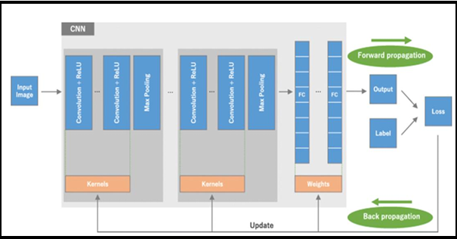
Figure 1.4.1: CNN Architectural Diagram
(Source: Ayeni, 2022)

2.4.2 Transfer Learning Approaches
Tan et al. (2023) explored how transfer learning can be used in a federated learning system in detecting breast cancer on the CBIS-DDSM mammography dataset. The researchers used MobileNet along with image preprocessing and the Synthetic Minority Oversampling Technique (SMOTE) to overcome imbalance in the dataset. One of the main advantages of the research is the application of transfer learning and federated learning that enhanced the performance of the classification, enhanced data privacy and decreased the reliance on centralised storage of data. Moreover, the analysis employed a relatively large dataset which enhances the soundness of the model assessment. However, this study was mainly based on one publicly accessible dataset which may not be representative enough of the heterogeneity of patient population, imaging equipment, and clinical conditions that can be faced in real healthcare settings. Even though the CBIS-DDSM dataset is a well-known and popular dataset in breast cancer research, it is possible that dependence on only one dataset could limit the dependability of the results when transferred to other healthcare contexts. Therefore, even though the findings have proved that transfer learning is indeed effective in detecting breast cancer, it needs to be further validated with several datasets and real-world clinical data to have full generalisation of the results. The research lends a good case for the adoption of transfer learning methods within the project since they help enhance the accuracy of classification and efficiency of the model.

2.4.3 Comparative Analysis
Transfer learning models, such as VGG16, ResNet, and DenseNet, have typically improved over traditional CNN architectures due to their ability to utilise pretrained knowledge available with large-scale image bases. The benchmarking dataset used in research works includes MIAS, CBIS-DDSM, and BreakHis. Several studies report accuracies above 90%, indicating promising performance of deep learning approaches (Meva et al., 2026). However, these results are not directly comparable because datasets, pre-processing procedures, architectures and evaluation protocols differ between studies. The datasets used are commonly accepted and mostly used for studying breast cancer. Hence, they add credibility to the results of researches. In addition, CNNs easily overfit small datasets while ResNet and DenseNet are highly computational. The low diversity of openly accessible datasets can also decrease the generalisability of the results to real-world clinical practice, where the demographics of patients, imaging equipment, and image quality can greatly differ. The uniformity of the performances demonstrated in various studies justifies the use of the transfer learning-based CNN models in the project.
Study | Dataset | Model | Accuracy
Sharma et al., 2024 | CBIS-DDSM | CNN | 99.67%
Mahmood et al., 2022 | MIAS and Private Dataset | Deep CNN-Based Model | 97.00%
Kim and Kim, 2024 | CBIS-DDSM | ResNet | 99.24%
Sayin et al., 2025 | BreakHis | Xception | 89.00%
Liao et al., 2023 | Mammography images | DenseNet-Based Deep Learning System | 87.20%
Table 1.1: Summary of Previous Studies on Deep Learning-Based Breast Cancer Detection
Table 1.1 is a summary of the selected research on deep learning-based breast cancer detection using diverse datasets and architectures of the model. The results show that deep learning models are characterised by high accuracy in breast cancer diagnosis. Sharma et al. (2024) achieved the highest accuracy (99.67% with a CNN model) with CBIS-DDSM whereas Kim and Kim (2024) achieved the highest accuracy (99.24% with a ResNet architecture) with the same dataset. A deep CNN-based model trained on MIAS and private mammography datasets gave Mahmood et al. (2022) an accuracy of 97.00%. Conversely, Sayin et al. (2023) and Liao et al. (2023) found lower accuracies at 89.00% and 87.20, respectively, which indicates that the performance of the model can depend on the qualities of the dataset, the quality of the images, sample size, and the complexity of classification. Even though other datasets like CBIS-DDSM, MIAS and BreakHis are popular and valid benchmark datasets, most studies are based on one dataset only which may restrict their extrapolation of the results to the clinical setting. However, the high performance attained in several studies shows that CNN and transfer learning methods are effective in detecting breast cancer and can be used in the project. Table 1.2 shows the comparison of the most popular deep learning models applied in the detection of breast cancer.
Model | Strengths | Limitations | Suitability for Project
CNN | Automatically extracts image features and achieves high classification accuracy. | Requires large datasets and may suffer from overfitting on small datasets. | Suitable as the baseline model.
VGG16 | Simple architecture and effective feature extraction through transfer learning. | Large number of parameters increases computational cost. | Suitable for transfer learning experiments.
ResNet50 | Addresses vanishing gradient problems and performs well on deep architectures. | Requires higher computational resources. | Highly suitable due to strong classification performance.
DenseNet121 | Improves feature reuse and reduces information loss between layers. | More complex architecture and longer training times. | Suitable for performance comparison.
Traditional Machine Learning (SVM, Random Forest) | Lower computational requirements and easier implementation. | Requires manual feature extraction and often produces lower accuracy than deep learning models. | Useful as a benchmark model.
Table 1.2: Comparison of Deep Learning Models for Breast Cancer Detection

2.4.4 Existing Breast Cancer Detection Systems
A number of deep learning-driven breast cancer detection models have been created to enhance the accuracy of diagnoses and aid in making clinical decisions. Diagnostic systems based on CNN are among the most popular as they are able to automatically derive relevant features of mammography and histopathological images. Research by Mahmood et al. (2022) and Sharma et al. (2024) revealed that CNN models are able to classify breast cancer with high accuracy of 97.0% and 99.67, respectively, which means that they are effective in identifying breast cancer. Nonetheless, such systems typically require high-quality and massive datasets and can be overfitted when they are trained with small datasets. ResNet systems have also demonstrated positive results in the diagnosis of breast cancer. According to Kim and Kim (2024) a ResNet model achieved an accuracy of 99.24% on the CBIS-DDSM dataset. The learning architecture that is left after residual learning provides better feature extraction and enhanced classification. Likewise, mammographic images have been analysed using a DenseNet-based system. Liao et al. (2023) created a deep learning system based on DenseNet, which had an accuracy rate of 87.2 per cent in classifying benign and malignant breast lesions. Despite the fact that DenseNet enhances the flow of information between network layers, its efficiency can be altered with regard to the characteristics of a dataset and image quality. Although the current systems have been successful, other challenges include overfitting, imbalance in the dataset, and poor generalisability. The proposed project instead focuses on a ResNet50 transfer-learning prototype and explicitly evaluates the effect of class imbalance through class-level metrics and majority-class comparison.
ResNet50 was selected because residual connections support the training of deep networks while pretrained ImageNet weights provide reusable visual features. Compared with a custom CNN, transfer learning reduces the need to learn all features from the limited medical dataset. VGG16 has a larger parameter burden, while DenseNet121 uses more complex feature connectivity. ResNet50 therefore provides a practical balance between feature-learning capability, transfer-learning availability and computational feasibility for the Google Colab environment.

2.5. Research Gaps in Existing Literature
Despite many researches which show that deep learning models could improve the process of breast cancer detection, there are still many gaps in researches. Overfitting remains one of the most challenging problems, because the deep learning models work very good on training data, but fail to work on new data. This issue is primarily due to the fact that most of the research employs small or limited datasets, which limits the capability of models to be effectively generalised to the real clinical setting (Basurto-Hurtado et al., 2022). Another difficulty is the imbalance in datasets, where certain datasets have higher numbers of benign images compared to those affected by malignancy, and this can impact the classification performance. Another gap concerns evaluation: high overall accuracy may conceal poor minority-class performance when datasets are imbalanced. This creates a need for class-specific metrics and baseline comparison alongside accuracy. These gaps are filled by this project through a combination of ResNet50 transfer learning, class-aware evaluation, joint accuracy and majority-class baseline in comparison, which gives the project-specific approach to evaluate whether so-called high accuracy is a true discrimination between benign and malignant images.

2.6 Chapter Summary
This chapter has provided an overview of the literature relating to automated classification of breast cancer using histopathological images through deep learning. It has focused on the clinical significance of correct distinction between benign and malignant tissues, along with the characteristics of the BreakHis dataset such as varying magnifications and imbalanced classes. Prior studies have shown that convolutional neural networks have the ability to automatically learn complex morphological, texture and spatial features in the form of deep features from histopathological images, thus minimizing reliance on hand-crafted features. Transfer learning techniques have been discussed as well as the role of pretrained models like ResNet50. Residual connections in ResNet50 enable training of deep networks and deep feature learning. Some existing studies have shown promising classification results, but still there are limitations like class imbalance, overfitting, lack of external validation, non-uniform pre-processing techniques and lack of interpretability. Based on the identified research gaps, it is justified to design a ResNet50-based transfer learning model for binary classification of the BreakHis images. This is presented in the next chapter.

3. Project Design

3.1 Introduction
The project design defines the technical and methodological decisions used to develop and evaluate a ResNet50-based breast histopathological image-classification prototype. The project aims to utilise a medical image dataset to automatically classify breast cancer cases to support healthcare professionals in the diagnostic process. The further development of deep learning models has been proven by the growing use of artificial intelligence in medical image analysis. This can enhance the accuracy of diagnosis and reduce the time taken in making clinical decisions. The project is based on a Data Science and Machine Learning project template which comprises parameters. Some of them are image pre-processing, model development, dataset selection, training, and evaluation. The inclusion of techniques of transfer learning to improve the performance of the classification and the training requirements. The design document describes the project domain, target users, work plan and evaluation method. The design gives a systematic guideline towards the creation of a functioning breast cancer detection.

3.2 Project Design
The project adheres to the Data Science and Machine Learning project template. The project aims at creating an intelligent breast cancer detection system through deep learning techniques of classifying medical images. The template is appropriate since it contains activities like data collection, data preprocessing, creation of predictive models, testing and training of the model. The current project adopts a systematic approach that involves data collection, image preprocessing, modeling, classification, and performance evaluation. The project falls within the field of healthcare and medical image analysis where AI can be used to aid disease diagnosis and clinical decision-making.

3.3 Domain and Target Users
The project is a part of the healthcare and medical image analysis field where artificial intelligence methods are applied to assist in disease diagnosis and clinical decision-making. Radiologists, pathologists and healthcare providers involved in the diagnosis of breast cancer are the major users of the system. The system serves to provide decision support in that it will automatically categorise images of breast cancer as benign or malignant. The system can assist with the burden of diagnostics as it offers rapid image classification and can be used to increase efficiency and facilitate earlier breast cancer detection. The detection of breast cancer is a key field of health care since early diagnosis is likely to increase the effectiveness of the treatment and the survival of patients (Barrios, 2022). The system assists these users by providing automated image classification and decision support. The system consists of several interconnected stages.

3.4 Dataset Selection and Management
The system uses the BreakHis dataset of histopathological images of breast cancer, including 7909 microscopic images of 82 patients. The data consists of both benign and malignant tumour images at various magnifications (40X, 100X, 200X and 400X). In the initial step, the datasets are gathered and classified into benign and malignant groups to facilitate binary classification. The second step is data analysis to check image quality and detect any missing, duplicate or damaged image files. In the third step, the images are preprocessed, which involves resizing all images to a common resolution of 224 × 224 pixels and normalisation of pixel values to enhance the efficiency of model training (Kaggle.com, 2020). The fourth phase applies data augmentation to the training images using rotation, horizontal flipping and zooming to increase image variation. Class imbalance is a major characteristic of the BreakHis dataset because malignant images substantially outnumber benign images. The effect of this imbalance is therefore considered during model evaluation through class-level metrics, balanced accuracy and majority-class baseline comparison. In the fifth step, the data is split into training, validation and testing groups. The transfer learning model (ResNet50) is trained using the training dataset, and the validation dataset is used to track the performance of the model during training. The dataset was stratified into training, validation and testing subsets using an 80:20 split followed by an 80:20 split of the training portion, resulting in approximately 64% training, 16% validation and 20% testing data. Lastly, the performance of classification in terms of accuracy, precision, recall, F1-score and confusion matrix is tested using the testing dataset. This formal data management process ensured consistency, reliability and model development.
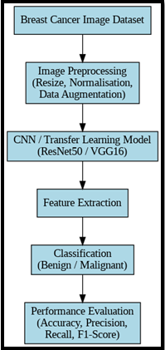
Figure 3.1: Workflow diagram
(Source: self-developed)
Component | Tool
Programming Language | Python
Deep Learning Framework | TensorFlow / Keras
Image Processing | OpenCV
Data Manipulation | Pandas, NumPy
Visualisation | Matplotlib
Development Platform | Google Colab
Dataset | BreakHis

Table 3.1: Technologies and Tools Used in the Project

3.5 Technologies and Methods
Python was used to develop the system, as it has a lot of support for machine learning and deep learning applications. CNN model was assessed with the help of TensorFlow and Keras, and the image preprocessing processes were assisted with OpenCV (Kharade et al., 2023). Data manipulation and management were done using pandas and NumPy. Modelling performance and experimental results were visualised using Matplotlib. CNN was selected because it can automatically learn spatial features such as textures, edges and morphological patterns from image data. Transfer learning is also relevant in this project since determining deep learning models using only limited datasets and using only limited computational power is both costly and time-intensive. In transfer learning, an existing trained model on a large image dataset like ImageNet is re-optimised for a new classification task. ResNet50 was selected because its residual connections support deep feature extraction while pretrained ImageNet weights reduce the need to learn visual features from the relatively limited medical dataset. Compared with a custom CNN, transfer learning reduces training requirements compared with VGG16 and DenseNet121, ResNet50 provides a practical balance between model depth, and feature extraction capability and computational feasibility. The model does not need to learn everything about the image features and this is substituted with the prior knowledge acquired to classify the breast cancer image. This reduces the training time, enhances the classification performance and aids in minimising over-fitting in cases of a limited medical dataset (Zhenfei et al., 2025). The project introduces a class-imbalance-aware evaluation approach as its main project-specific contribution. The prototype uses class-level precision, as well as recall, F1-score, and balanced accuracy and majority-class baseline to identify whether the model really differentiates between benign and malignant images, rather than just using a metric of accuracy. This gives a stronger analysis of breast cancer classification as compared to reporting overall accuracy only.

3.6 Project Plan
The project can be done over a series of planned stages. The initial step was a literature review and finding appropriate datasets of breast cancer images. Carrying out a literature search and selecting appropriate sets of breast cancer image data such as BreakHis constitute the first phase (Murty et al., 2024). It then goes ahead to cover preparations of datasets and image processing steps, which may include resizing, normalisation and data augmentation. The next step is building a deep learning model based on Convolutional Neural Networks (CNNs) and a transfer learning strategy. After that, training and validation of the model are done using the prepared dataset. The formulated model then be evaluated, and the performance indices of the classification process such as accuracy, precision, recall and F1-score, will be evaluated. Analysis of the results and writing up of the report will be the final phase. There are several threats to project implementation success that should be considered. One such threat could be related to limited dataset availability and imbalanced datasets, which might result in lower quality results as well as higher chances of overfitting. The problem can be solved by using data augmentation methods and choosing balanced datasets for work. Another problem may be associated with the increased need for computational resources needed to train deep learning algorithms. This threat will be managed using the GPU-supported environment provided by Google Colab.
Phase | Activity | Main Output
1 | Project definition and requirements | Project specification
2 | Literature review | Reviewed literature
3 | Dataset selection and inspection | BreakHis dataset
4 | Data preprocessing and augmentation | Prepared dataset
5 | CNN architecture selection and design | ResNet50 design
6 | Model implementation | Working prototype
7 | Model training and validation | Trained model
8 | Testing and performance evaluation | Metrics and confusion matrix
9 | Critical analysis and baseline comparison | Findings
10 | Report writing and revision | Final report
11 | Final notebook testing | Completed implementation
12 | Final submission | Submitted project
Table 3.2: Project schedule table
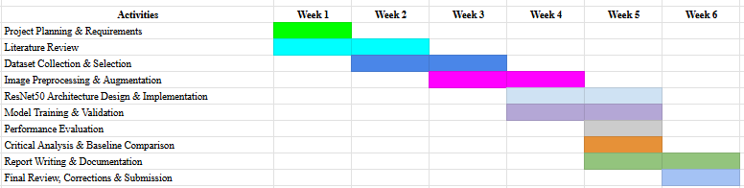
Figure 3.2: Gantt Chart
(Source: self-developed)

3.7 Evaluation Strategy
The performance of the breast cancer detection system is evaluated using standard classification metrics commonly applied in machine learning and medical image analysis. Accuracy used to measure the overall proportion of correctly identifying malignant cases without generating excessive false positives. Recall is used to evaluate the model’s performance on real cancer cases because it is very important in medical diagnosis where missing the cancer cases could be disastrous. F1-score is used to give a good balance between accuracy and recall. Additionally, a confusion matrix is developed to aid in the analysis of classification results so as to come up with true positives, true negatives, false positives and false negatives (Moslemi et al., 2025). Besides accuracy, classification behaviour is assessed using the confusion matrix to determine the false positive and false negative predictions. Precision needs to be used to indicate what percentage of positive predictions are identified correctly, and recall is used to determine how the model is able to identify cases of malignancy. This focuses especially on the notion of recall since the consequences of a missed cancer diagnosis could be quite serious in clinical terms. F1-score give a balanced precision and recall. The results of the last model contrasted with the results of the earlier research to determine whether the suggested solution can prove itself as a satisfactory performance. The objectives of the project would be determined by the degree to which the trained CNN model would show a very high level of classification performance when using the test dataset of breast cancer images. The model used to identify the success of the project by the capability to distinguish successfully between benign and malignant images of breast cancer and provide acceptable accuracy, precision, recall and F1-score values. Specific attention is given to the aspect of recall since properly recognising malignant cases is essential in medical diagnosis. The majority-class baseline assumes that every test image is assigned to the malignant class. Its performance provides a reference point for determining whether the ResNet50 model improves on a classifier that does not learn meaningful class-specific features.

3.8 Chapter Summary
This project design introduces a framework for creating a CNN-based breast cancer detection system. In the design, medical image analysis, transfer learning, and performance evaluation methods are included to help ensure correct classification of breast cancer cases. The design establishes the dataset, technical architecture, implementation plan, project schedule and class-aware evaluation strategy required to develop and critically assess the prototype

4. Implementation

4.1 Introduction
The feature prototype is aimed at creating an automated method of breast cancer classification with the help of deep learning techniques. The prototype shows that it is possible to detect breast cancer using Convolutional Neural Networks (CNNs) and transfer learning based on histopathological images. An existing ResNet50 model was used to categorise the images into benign and malignant images. The prototype is the basic functionality of the final system and offers early evaluation of model performance. The implementation aids in testing the capability of deep learning to aid proper breast cancer diagnosis and further development of the system.

4.2 Model Architecture
The prototype applies a ResNet50 transfer learning model in classifying breast cancer images. ResNet50 is a deep convolutional neural network, which is pretrained on the ImageNet dataset (Behar and Shrivastava, 2022). The already trained feature extraction layers were left but extra layers were added to do binary classification. The architecture includes the ResNet50 base model, a Global Average Pooling layer, a dense layer with ReLU activation and an output layer with a sigmoid. The Adam optimiser and binary cross-entropy loss function were used to train the model. The metrics used to assess performance were classification accuracy and other common machine learning measures.
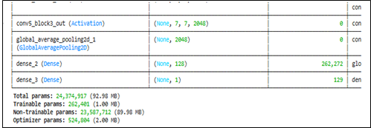
Figure 4.2.1: Model Summary
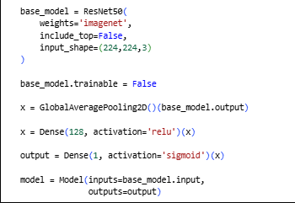
Figure 4.2.2: Model Construction Code
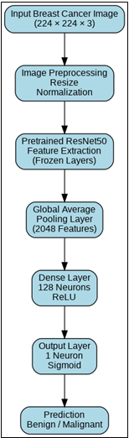
Figure 4.2.3: ResNet50 Architecture
Figure 4.2.1 illustrates the summary of the developed ResNet50 transfer learning model using Google Colab in TensorFlow and Keras. The ResNet50 pretrained network was used as the feature extractor backbone, where the output of the last convolutional layer is represented by feature maps that are 7 x 7 x 2048. Then, the Global Average Pooling operation was done to convert the 7 x 7 x 2048 feature maps to a one-dimensional vector with 2048 features in order to decrease computational complexity prior to the classification process. A dense layer with 128 neurons and ReLU activation function was used to extract the high-level representation of images, while a single-neuron layer with sigmoid activation function was added for the binary classification of the images into benign and malignant classes. In summary, the ResNet50 transfer learning model is a suitable architecture for the automatic breast cancer image classification because of the combination of pretrained feature extraction and task-specific classification layers. The architecture allows for reduction of computational complexity by using the pretrained convolutions while only training the new dense layers. The classification head was deliberately kept compact because the pretrained ResNet50 convolutional base already provides the principal feature extraction capability. Global Average Pooling reduces the convolutional representation before the 128-neuron dense layer, limiting the number of additional trainable parameters.

4.3 Development Environment
A breast cancer image-classification model was developed in Google Colab using Python. Google Colab was used as a platform for building a notebook for developing, training, and testing the ResNet50 neural network model. The TensorFlow framework and the Keras API were applied for loading the pre-trained ResNet50 architecture from ImageNet, creating the new classification layer, compiling the network, and making predictions. For numerical operations and management of multi-dimensional arrays, the NumPy package was used. Experimental results were organised by the Pandas library. Visualisation was done by means of the Matplotlib and Seaborn libraries visualisations of class distributions, training behaviour, confusion matrices and performance metrics were generated. Functions for computing such performance metrics as accuracy, precision, recall, F1-score, balanced accuracy and classification report were provided by the Scikit-learn package. Images from the BreakHis database were saved into directories and loaded in batches to avoid problems with memory consumption.

4.4 Transfer-Learning Implementation
Transfer learning was implemented through the ResNet50 architecture that was trained on the ImageNet dataset. The pretrained network provided previously learned convolutional filters that were capable of detecting visual features such as edges, textures, shapes, and complex spatial patterns. These qualities were ported to the prediction of benign and malignant Breast histopathology pictures in the BreakHis dataset. To remove original ImageNet classification layer, it loaded the ResNet50 Model with include_top = False (Hossain et al., 2022). Its pretrained parameters were also initially frozen thus not allowing them to be changed in the course of training. As a result, the histopathological images were only trained on the newly added classification layers. This approach reduced the number of trainable parameters and computational requirements compared with training the complete ResNet50 network from scratch, while providing pretrained visual representations for the classification task.
f = F_{ResNet50}​(x;θ_{ImageNet}​)
Where x is the image preprocessed unit, F_{ResNet50} is known as a pretrained convolutional network, and f is the extracted feature representation.

4.5 Feature Aggregation and Classification
The convolutional layer output features maps of ResNet50 were pooled using Global Average Pooling (Huang et al., 2025). This operation was successful in achieving down-sampling of every 2D feature map to a single value, and it implies that the number of parameters to be trained was smaller when compared to a flattening operation. Global Average Pooling is defined as:
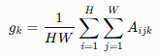
Where A_{ijk​} denotes the activation at spatial position (i,j) in feature map k, while H and W represent its dimensions. The resulting feature vector was passed through the custom classification head. Sigmoid activation function was used for the final output neuron.
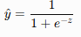
This produced a probability between 0 and 1. Probabilities below 0.5 were classified as benign and the values equal to or above 0.5 were classified as malignant. For a 224 × 224 input, the ResNet50 convolutional base produces a 7 × 7 × 2048 feature representation. Flattening this representation would produce 100,352 values, whereas Global Average Pooling reduces it to 2,048 features. This substantially reduces the dimensionality presented to the classification head and limits additional trainable parameters.

4.6 Model Compilation
The developed ResNet50-based model was then compiled to configure its learning process. Binary cross-entropy was chosen as the loss function because the classification task involved two distinct classes: malignant and benign. The loss function is defined by the following formula:
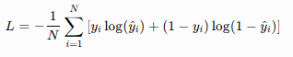
where yi​ represents the actual class label and y^​i​ denotes the predicted probability. This loss reduction aids in assuring that the estimated probabilities match their ground truth labels. Adam is an optimiser algorithm employed for updating the tunable parameters of our custom classification head layer. This algorithm is a combination of the adaptive learning rate algorithm and the momentum-based optimisation algorithm which allows for consistent and computationally feasible training. Accuracy was defined as the primary training metric used to determine the percentage of correct classifications of images per epoch.

4.7 Chapter Summary
The current chapter has discussed the implementation of the breast histopathological image classification model based on the ResNet50 architecture. The 2048-feature representation was passed through a 128-neuron ReLU dense layer and a sigmoid output layer for binary classification. The system was implemented in Google Colab using the Python programming language, as well as the TensorFlow and Keras machine learning frameworks and the corresponding set of libraries for numerical and graphical data processing. The transfer learning approach was implemented using pre-trained ImageNet weights of ResNet50 without its final classification layer. The convolutional base of the network was frozen and served for extracting relevant visual features from the BreakHis images, while the classification head was trained from scratch for the given task. Global Average Pooling was used for converting the resulting feature maps into a compact feature vector and thus reducing the number of learnable parameters. The model was compiled with the help of the binary cross-entropy loss function and the Adam optimiser.

5. Evaluation

5.1 Introduction
This chapter aims to analyse the performance of the ResNet50 transfer-learning prototype that was created in order to classify breast histopathological images into either benign or malignant classes. The evaluation examines class distribution, training and validation behaviour, test performance, confusion-matrix results and class-level metrics, with particular emphasis on whether overall accuracy represents balanced classification.

5.2 Class Distribution
Figure 5.2.1 indicates the distribution of the data in terms of class, and the malignant images (5429) greatly outnumbered the benign images (2480). This imbalance in classes can affect the behaviour of the classification model. Figure 5.2.1 shows that images belonging to the malignant category constituted roughly 68.64% of the data, whereas those belonging to the benign category constituted about 31.36%. Hence, the proportion of malignant to benign images was around 2.19:1. This imbalance creates a risk that the classifier will favour the malignant majority class, making overall accuracy potentially misleading. The model is exposed to malignant examples during training, and thus, the model learns that classifying the majority class results in relatively low classification losses. Thus, high accuracy could mask weak classification accuracy of the minority class. The class distribution needs to be taken into account while evaluating the accuracy of the final model.
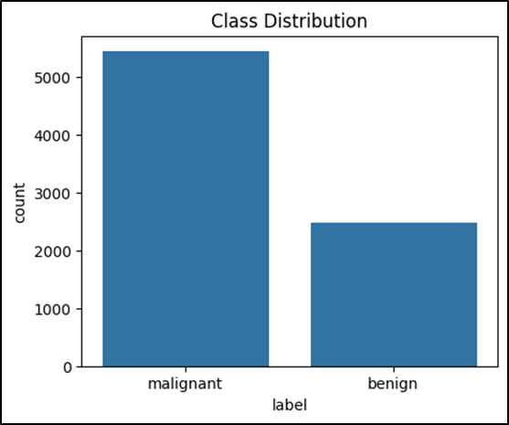
Figure 5.2.1: Class Distribution

5.3 Training and Validation Performance
Two epochs of the training process were carried out. The training and validation accuracy curves are represented in Figure 5.3.1. Training accuracy also rose from an average of 67.92 to 68.49, and validation accuracy also rose from an average of 70.12 to 70.99. The small improvement indicates limited learning during the two-epoch training period. Loss Curves of Figure 5.3.1 offer more details on the learning process. The decrease in training loss from about 0.6338 to 0.6215 suggests a better fit of the model to the training set. However, an increase in the validation loss from about 0.5965 to 0.6065 is observed. The decrease in training loss alongside increasing validation loss may indicate early overfitting. However, only two epochs were used, so a persistent overfitting pattern cannot be established. Thus, it is premature to say that there was no overfitting of the model.
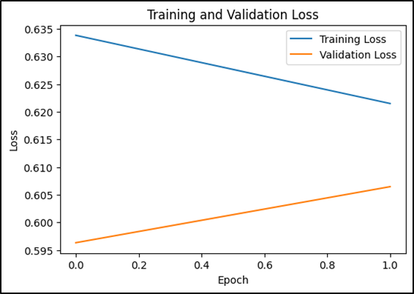
Figure 5.3.1: Loss Curve

5.4 Overall Test Performance
The accuracy achieved by the model during testing needs to be considered against the background of the distribution of classes and confusion-matrix results. The confusion matrix includes 1582 images for testing that have 1086 malignant images and 496 benign images. The model managed to classify 1110 images correctly, resulting in an accuracy of about 70.16%. While this is higher than the 68.65% baseline for the majority class, there is only modest improvement. Thus, it cannot be said that the model achieves accurate classification based on accuracy since the model heavily relies on the malignant class.

5.5 Confusion-Matrix Analysis
The confusion matrix tests the ResNet50 model on 1582 images as shown in Figure 5.5.1. Given the assumption that malignancy is the positive class, the ResNet50 model detected 1083 true positive samples, 27 true negative samples, 469 false positive samples, and 3 false negative samples. Consequently, the number of correct detections was 1110 samples out of 1582 test images, resulting in an accuracy of approximately 70.16%. From 1086 malignant samples, the ResNet50 model correctly classified 1083 malignant images, yielding a malignant sensitivity of approximately 99.72%, suggesting that only 3 malignant samples were misclassified as benign. On the other hand, the model classified 27 out of 496 benign samples correctly, giving a benign specificity of 5.44%. Malignant-class precision was around 69.78%, whereas the F1 score for the class was around 82.11%. On the other hand, benign-class recall was only 5.44%, and the F1 score for the class was around 10.27%. Balanced accuracy was around 52.58%, which indicates that the performance of the model was barely above chance level when equal weightage was provided to both classes. Despite the model performing very well on malignant images in terms of sensitivity, it classified 1552 out of 1,582 images in the test set as malignant. It demonstrates the prediction bias towards the malignant class. Hence, accuracy cannot be taken into account as a sign of reliable class discrimination.
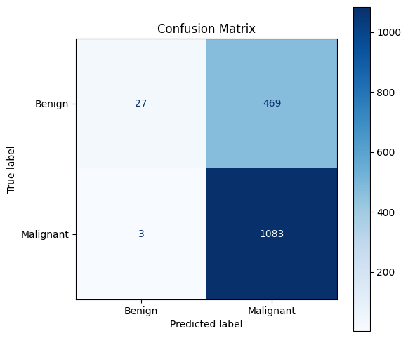
Figure 5.5.1: Confusion Matrix

5.6 Class-Level Performance
Table 5.6.1 and Figure 5.6.1 indicate that there is a significant difference in performance between the two classes. Precision of the benign class was 0.90, and recall was only 0.05, and the F1-score was 0.10. This implies that the majority of the images that were classified as benign were benign though the model marked very few of the real benign images. In the case of the malignant category, the precision, F1-score and recall were 0.70, 1.00 and 0.82 respectively. This high malignant recall indicates that the model was detecting nearly all the malignant images, and low precision means that many of the malignant images had been detected as such. On the whole, the findings presented at the class level show that the bias towards malignant predictions is strong and supports the necessity to analyze the overall accuracy and class-specific measures.
Class | Precision | Recall | F1-Score | Support
Benign | 0.90 | 0.05 | 0.10 | 496
Malignant | 0.70 | 1.00 | 0.82 | 1,086
Accuracy |  |  | 0.70 | 1,582
Macro Average | 0.80 | 0.53 | 0.46 | 1,582
Weighted Average | 0.76 | 0.70 | 0.60 | 1,582

Table 5.6.1: Classification Performance of the ResNet50 Model
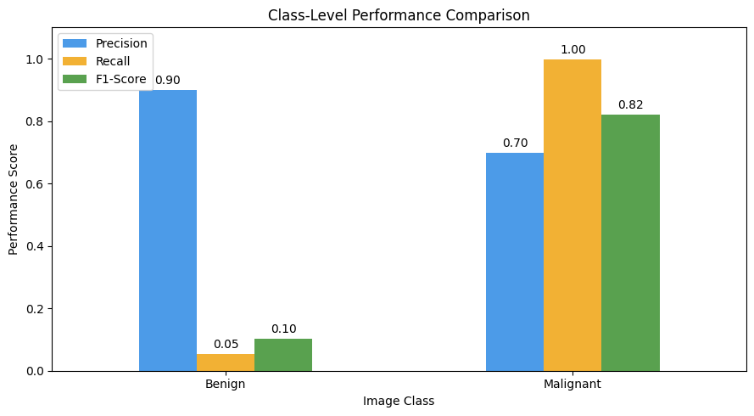
Figure 5.6.1: Class-level Performance Comparison

5.7 Effect of Class Imbalance
The dataset was imbalanced, with substantially more malignant images than benign images. The findings indicates that the imbalance of the classes of benign and malignant had a considerable effect on the boundary of the decision made by the model. Considering that malignant samples constituted 68.64% of the BreakHis dataset, the model based on the ResNet50 architecture became highly biased to the majority class. This can be observed from the test results, according to which out of 1,582 images, 1,552 images were classified as malignant. While the number of correct classifications of malignant cases amounted to 1083 of 1086 cases, only 27 of 496 benign cases were detected. Thus, the recall for malignant cases amounted to 99.72% while the recall for benign was 5.44%. The gap between overall accuracy and balanced accuracy demonstrates why accuracy alone provides an incomplete assessment of this imbalanced classifier. From a technical perspective, the model had high sensitivity but extremely low specificity.

5.8 Comparison With the Baseline
The majority-class baseline serves as a means of measuring whether the ResNet50 model learned discriminative features of the benign and malignant images. Given the fact that there were 1,086 malignant images among the total number of 1,582 test images, a classifier which predicts all the images to be malignant achieves 68.65% accuracy by not learning any image features. The accuracy of the ResNet50 classifier, according to the confusion matrix, is 70.16%, thus resulting in a gain of 1.51 percentage points compared to the majority-class baseline. However, the improvement was not significant and can hardly be considered as a good classification performance. The confusion matrix shows that the classifier classified 1,083 out of 1,086 malignant images correctly, while correctly classifying 27 out of 496 benign images. In other words, the classifier classified 1,552 out of 1,582 images to be malignant, showing the inclination to the majority class. The fact that the balanced accuracy is 52.58% means that the model performs even a bit better than randomly classifying the images. Comparison to the baseline gives us an important insight into the functioning of our model: even though the ResNet50 classifier performs better in terms of accuracy, the gain compared to the baseline is insignificant, and there is a very poor benign-class recall. This means that the prototype managed to learn the features of malignant images and did not learn how to form the decision boundary between two classes properly. Thus, further training and class-balancing measures are needed in order for the model to be used as a classifier of breast cancer.
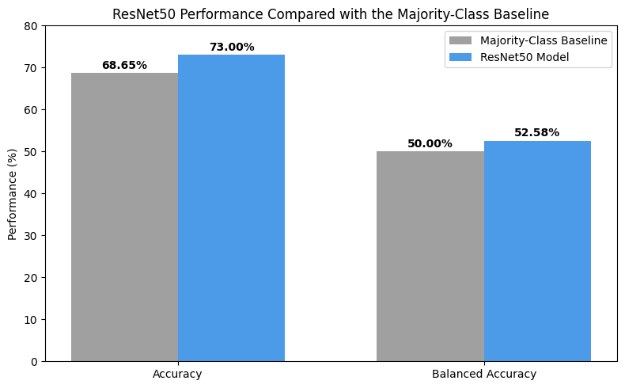
Figure 5.8.1: ResNet50 Performance Compared with the Majority-Class Baseline

5.9 Critical Evaluation and Limitations
The prototype was technically feasible but failed to attain balance in classification. The prototype was able to achieve very high malignant recall of 99.72%, but only achieved benign recall of 5.44%, showing that the prediction was heavily biased towards the malignant class. Furthermore, the low balanced accuracy of 52.58% is evidence that overall accuracy does not accurately reflect the efficacy of the prototype. There were other limitations in the evaluation process including the training process that was done over only two epochs, thus making it impossible to evaluate for convergence and optimisation. Moreover, testing was done over the BreakHis data itself without any external validation.

5.10 Chapter Summary
Evaluation proved that it is technically feasible to run ResNet50 transfer learning with binary classification of BreakHis histopathological images. Nevertheless, the findings showed that there was high imbalance of classes and prediction bias in favor of malignant images. The malignant recall was 99.72%, the benign recall was 5.44 with the balanced accuracy being 52.58. The only limitation revealed in comparison with the majority-class baseline was that overall accuracy did not improve significantly, and thus the model failed to provide discrimination between the two classes as well as possible. The brief two-epoch training, lack of independent external validation and lack of established separation at the patient level further constrain the generalisability of the results. Hence, the prototype has potential as a technical proof of concept but additional optimisation and validation is necessary before reliability can be achieved.

6. Conclusion

6.1 Conclusion
This project examined the use of Deep learning and transfer learning to classify breast cancer using histopathological images of BreakHis dataset. An image classification model was developed in Python with the help of the TensorFlow and Keras packages, which is a ResNet50 convolutional neural network with Global Average Pooling and a classification head that is task-specific binary classification between benign and malignant images. The test showed that the model was technically able to detect malignant images with a malignant recall of 99.72%. Nevertheless, benign recall was only 5.44, whereas the balanced accuracy was 52.58%, which means that there was a significant bias in favor of the malignant majority group. The results hence show that the overall accuracy cannot be used to assess an imbalanced medical image classifier. The improvement of the comparison to the majority-class baseline was limited as well, which indicates the necessity of stronger assessment. Moreover, the two-epoch training period, absence of independent external validation and not verified patient-level separation restricts generalisability of the results. On the whole, the project shows that ResNet50 Transfer Learning is technically viable to deal with the task of breast histopathological image classification, however, the prototype needs additional optimisation and validation prior to any clinical use.

6.2 Recommendations
The developmental error to be made in the future should be the better classification balance and reliability of the ResNet50 prototype. Aweighting or balanced sampling by classes is to be considered since the current results demonstrate a significant dissimilarity amid malignant and benign recognition. Additional data augmentation of rotation, flipping, zooming and contrast enhancement might additionally be reviewed to enhance image diversity and decrease overfitting. Transfer-learnings such as DenseNet121 and Efficient-Net might be trained against ResNet50 with the same pre-processing and test settings to establish whether other more balanced architectures can be trained. The transfer learning method is also relevant since trained deep CNNs models can facilitate useful feature learning in cases where the medical data are relatively small (Zhenfei et al., 2025). Patient-level separation and external datasets not affiliated with other hospitals should also be implemented in future assessments to give a better evaluation of the generalisability. Lastly, elucidate the possibility of adding explainable artificial intelligence methods like Grad-CAM that allow determining the regions of the image that affect model predictions and enhance interpretability among healthcare personnel (Talaat et al., 2024). They would enhance the credibility, openness and utility of the proposed breast cancer classification method.

References
Abunasser, B.S., Al-Hiealy, M.R.J., Zaqout, I.S. and Abu-Naser, S.S., 2023. Convolution neural network for breast cancer detection and classification using deep learning. Asian Pacific journal of cancer prevention: APJCP, 24(2), p.531. DOI:10.31557/APJCP.2023.24.2.531
Ayeni, J., 2022. Convolutional neural network (CNN): the architecture and applications. Applied Journal of Physical Science, 4(4), pp.42-50. https://doi.org/10.31248/AJPS2022.085
Barrios, C.H., 2022. Global challenges in breast cancer detection and treatment. The Breast, 62, pp.S3-S6. https://doi.org/10.1016/j.breast.2022.02.003
Basurto-Hurtado, J.A., Cruz-Albarran, I.A., Toledano-Ayala, M., Ibarra-Manzano, M.A., Morales-Hernandez, L.A. and Perez-Ramirez, C.A., 2022. Diagnostic strategies for breast cancer detection: From image generation to classification strategies using artificial intelligence algorithms. Cancers, 14(14), p.3442. https://doi.org/10.3390/cancers14143442
Behar, N. and Shrivastava, M., 2022. ResNet50-Based Effective Model for Breast Cancer Classification Using Histopathology Images. Computer Modeling in Engineering & Sciences (CMES), 130(2). DOI: 10.32604/cmes.2022.017030
Carriero, A., Groenhoff, L., Vologina, E., Basile, P. and Albera, M., 2024. Deep learning in breast cancer imaging: state of the art and recent advancements in early 2024. Diagnostics, 14(8), p.848. https://doi.org/10.3390/diagnostics14080848
Chianumba, E.C., Ikhalea, N., Mustapha, A.Y., Forkuo, A.Y. and Osamika, D., 2023. Exploring the role of AI and machine learning in improving healthcare diagnostics and personalized medicine. Journal of Frontiers in Multidisciplinary Research, 4(1), pp.177-182. https://doi.org/10.54660/.IJFMR.2023.4.1.177-182
Harrison, P., Hasan, R. and Park, K., 2023. State-of-the-art of breast cancer diagnosis in medical images via convolutional neural networks (CNNs). Journal of Healthcare Informatics Research, 7(4), pp.387-432. https://doi.org/10.1007/s41666-023-00144-3
Hossain, M.B., Iqbal, S.H.S., Islam, M.M., Akhtar, M.N. and Sarker, I.H., 2022. Transfer learning with fine-tuned deep CNN ResNet50 model for classifying COVID-19 from chest X-ray images. Informatics in Medicine Unlocked, 30, p.100916. https://doi.org/10.1016/j.imu.2022.100916
Huang, C.C., Chang, C.C. and Chang, C.M., 2025. Evaluating convolutional neural networks using residual blocks and global average pooling techniques for predicting sediment concentration. Scientific Reports, 15(1), p.35278. https://doi.org/10.1038/s41598-025-19161-w
Hussain, S., Mubeen, I., Ullah, N., Shah, S.S.U.D., Khan, B.A., Zahoor, M., Ullah, R., Khan, F.A. and Sultan, M.A., 2022. Modern diagnostic imaging technique applications and risk factors in the medical field: a review. BioMed research international, 2022(1), p.5164970. https://doi.org/10.1155/2022/5164970
Kaggle.com 2020. BreakHis. https://www.kaggle.com/datasets/ambarish/breakhis
Karera, A., Engel-Hills, P. and Davidson, F., 2024. Radiology image interpretation services in a low-resource setting: medical doctors' experiences and the potential role of radiographers. Radiography, 30(2), pp.560-566. https://doi.org/10.1016/j.radi.2024.01.009
Khan, A.Q., Touseeq, M., Rehman, S., Tahir, M., Ashfaq, M., Jaffar, E. and Abbasi, S.F. (2025). Advances in breast cancer diagnosis: a comprehensive review of imaging, biosensors, and emerging wearable technologies. Frontiers in Oncology, 15. doi:https://doi.org/10.3389/fonc.2025.1587517.
Kharade, J., Deshmukh, P., Behl, G., Nidhi, Rauf, R.F. and Gupta, K., 2023, June. Analysis on Prediction of Crop Diseases Using TensorFlow with Keras and OpenCV Technique of Deep Learning. In International Conference on Data Science and Big Data Analysis (pp. 87-98). Singapore: Springer Nature Singapore. https://www.researchgate.net/profile/Jyoti-Kharade-3/publication/404399182_Analysis_on_prediction_of_crop_diseases_using_TensorFlow_with_Keras_and_OpenCV_technique_of_deep_learning/links/69f87199b1dace04f143ff84/Analysis-on-prediction-of-crop-diseases-using-TensorFlow-with-Keras-and-OpenCV-technique-of-deep-learning.pdf
Kim, T.H. and Kim, S.Y., 2024. Predictive Analysis of Breast Cancer from Full-Field Digital Mammography Images using Residual Network. Scalable Computing: Practice and Experience, 25(6), pp.5056-5069. DOI 10.12694/scpe.v25i6.3397
Liao, T., Li, L., Ouyang, R., Lin, X., Lai, X., Cheng, G. and Ma, J., 2023. Classification of asymmetry in mammography via the DenseNet convolutional neural network. European journal of radiology open, 11, p.100502. https://doi.org/10.1016/j.ejro.2023.100502
Mahmood, T., Li, J., Pei, Y., Akhtar, F., Rehman, M.U. and Wasti, S.H., 2022. Breast lesions classifications of mammographic images using a deep convolutional neural network-based approach. Plos one, 17(1), p.e0263126. https://doi.org/10.1371/journal.pone.0263126
Meva, D.T., Popat, K., Kukadiya, H. and Jariwala, N., 2026. Deep learning-based breast cancer detection with customized ensemble attention. Scientific Reports. https://doi.org/10.1038/s41598-026-50563-6
Moslemi, D., Hassan Hosseini, S.M., Jafarian, E. and Jamshidi, M., 2025. Benchmarking Deep Learning Algorithms for Breast Cancer Detection: A Comprehensive Review and Evaluation Across Public Imaging Datasets. InfoScience Trends, 2(4), pp.11-24. https://doi.org/10.61186/ist.202502.04.02
Murty, P.S.C., Anuradha, C., Naidu, P.A., Mandru, D., Ashok, M., Atheeswaran, A., Rajeswaran, N. and Saravanan, V., 2024. Integrative hybrid deep learning for enhanced breast cancer diagnosis: leveraging the Wisconsin Breast Cancer Database and the CBIS-DDSM dataset. Scientific Reports, 14(1), p.26287. https://doi.org/10.1038/s41598-024-74305-8
Nasser, M. and Yusof, U.K., 2023. Deep learning based methods for breast cancer diagnosis: a systematic review and future direction. Diagnostics, 13(1), p.161. https://doi.org/10.3390/diagnostics13010161
Sayın, İ., Soydaş, M.A., Mert, Y.E., Yarkataş, A., Ergun, B., Yeh, S.S. and Üvet, H., 2023. Comparative analysis of deep learning architectures for breast cancer diagnosis using the BreaKHis dataset. arXiv preprint arXiv:2309.01007. https://arxiv.org/pdf/2309.01007
Sharma, R 2024. Image Preprocessing, Segmentation, and Classification Techniques for Detection of Breast Cancer using Mammographic Images. http://gmsarnjournal.com/home/wp-content/uploads/2025/04/vol19no4-8.pdf
Talaat, F.M., Gamel, S.A., El-Balka, R.M., Shehata, M. and ZainEldin, H., 2024. Grad-CAM enabled breast cancer classification with a 3D inception-ResNet V2: Empowering radiologists with explainable insights. Cancers, 16(21), p.3668. https://doi.org/10.3390/cancers16213668
Tan, Y.N., Tinh, V.P., Lam, P.D., Nam, N.H. and Khoa, T.A., 2023. A transfer learning approach to breast cancer classification in a federated learning framework. IEEe Access, 11, pp.27462-27476. Digital Object Identifier 10.1109/ACCESS.2023.3257562
Wang, L., 2024. Mammography with deep learning for breast cancer detection. Frontiers in oncology, 14, p.1281922. https://doi.org/10.3389/fonc.2024.1281922
WHO (2025). Breast cancer. [online] World Health Organization. Available at: https://www.who.int/news-room/fact-sheets/detail/breast-cancer.
Zhenfei, W., Ali, M.M., Sahibzada, K.I., Maqsood, F., Rehman, N.U., Aftab, M., Zia, Q., Weiyan, H. and Wei, D.Q., 2025. Hybrid feature extraction for breast cancer classification using the ensemble residual VGG16 deep learning model. Current Bioinformatics, 20(2), pp.149-163. DOI: 10.2174/0115748936333380240816053223

